# NETWORK LAYER

## NETWORK LAYER SERVICES

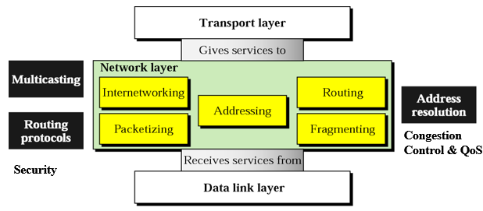

1. Source to Destination delivery (host)
2. Packetizing  
   Encapsulating & Decapsulating payload
3. Routing  
   Finding best route
4. Inter-Networking  
   provides logical connection b/w networks.
5. Logical Addressing
6. Error, Flow, Congestion control, Security etc.

## PACKET SWITCHING

Method of data transmission where the message is broken into smaller units called **packets**.

Each packet travels independently through the network, possibly taking different routes.

At the destination, packets are **reassembled** to form the original message.

TYPES

1. **DATAGRAM** (Network Layer)  
   Each packet treated independently.  
   No dedicated path
2. **VIRTUAL CIRCUIT** (Data link Layer)  
   A logical path is established

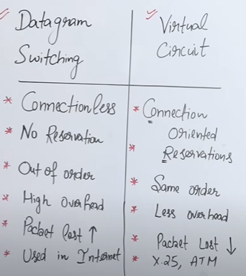

## FACTORS AFFECTING PERFORMANCE

1. **Throughput**  
   Amount of data successfully delivered   
   over time.
2. **Delay**  
   Time taken for a packet to reach destination.
3. **Packet Loss**  
   Number of packets dropped due to congestion or errors.
4. **Jitter**  
   Variations in packet arrival time.

### IMPROVEMENT TECHNIQUES

1. Efficient routing algorithms
2. Congestion control
3. Load balancing

## IPV4 ADDRESSES

A 32bit address, uniquely & universally defines the connection of device to the internet.

2 Devices on internet can never have same IP address at one time.

**Structure**: |Network ID | Host ID|

ADDRESS SPACE ?Total number of addresses used by a protocol.  
For 32 bits -> 232 = 4billion+ if no restrictions

### NOTATIONS

1. **BINARY** : 32 bits or 4 bytes/octet  
   00010001 01011011 00111010 10101101
2. **DOTTED** : 17.91.58.173 (Above into decimal)  
   - There must be no leading zero at any octet  
   - Each number needs to be <= 255

## CLASSFUL ADDRESSING

Before 1980s, IP 32 bits were divided as   
8 bits Network and 24 bits Hosts,  
But this was not feasible hence

Adress space was divided into 5 classes : A B C D E

### CLASS A

* First bit fixed as : **0** _ _ _ _ _ _ _  
  Range [ **0**(*0*0000000) to **127**(*0*1111111) ]
* Total IP Addresses in A : **231**
* 1st octet represents Network ID i.e. 8 bits  
  Hence total Networks : 27 = 128-2 = 126
* Rest 3 octets represent Hosts ID i.e. 24 bits   
  hence total Hosts per n/w : 224 -2
* Default mask : 255.0.0.0  
  Perform and with address, u will get class

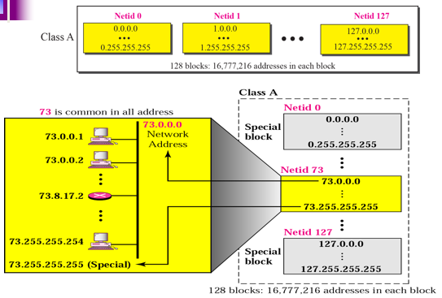

### CLASS B

* First 2 bits fixed as : **1 0** _ _ _ _ _ _  
  Range ( **128**(*10*000000) to **191**(*10*111111) )
* Total IP Addresses in B : **230**
* First 2 octet – Network ID i.e. 16 bits  
  Hence total Networks : 214 = 16384-2 = 16382
* Rest 2 octets - Hosts ID i.e. 16 bits   
  and total Hosts per n/w : 216 -2
* Default mask : 255.255.0.0  
  Perform and with address, u will get class

### CLASS C

* First 3 bits fixed as : **110** _ _ _ _ _  
  Range ( **192**(*110*00000) to **223**(*110*11111) )   
  in decimal dotted
* Total IP Addresses in B : **229**
* First 3 octet – Network ID i.e. 24-3 bits  
  Hence total Networks : 221
* Rest 1 octet - Hosts ID i.e. 8 bits   
  and total Hosts per n/w : 28 -2
* Default mask : 255.255.255.0  
  Perform and with address, u will get class

### CLASS D

* First 4 bits fixed as : **1110** _ _ _ _  
  Range ( **224**(11100000) to **239**(11101111) )   
  in decimal dotted
* Total IP Addresses : 228
* No sub division, reserved for multi cast, broadcast etc.

### CLASS E

* First 4 bits fixed as : **1111** _ _ _ _  
  Range ( **240**(11100000) to **255**(11101111) )   
  in decimal dotted
* Total IP Addresses : 228
* No sub division, reserved for Military

### SUBNETTING

Network ID remains untouched.  
Host ID Bits one by one

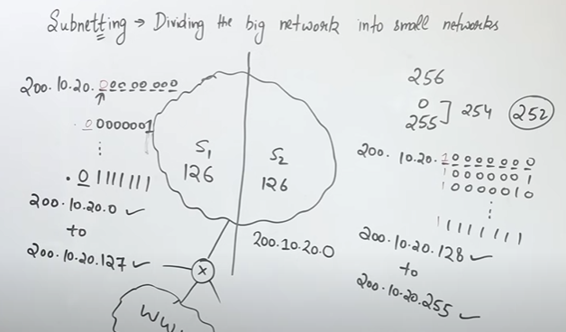

**SUBNET MASK ?**  
TO identify subnets  
class c : 255.255.255.(no of bits fixed as 1 followed by 0)

### CONS OF CLASSFULL ADDRESSING

1. IP wastage in CA, CB less n/w more hosts
2. Maintenance, time consuming
3. Error prone

## CLASSLESS ADDRESSING

* In 1993, No classes
* Blocks of addresses are provided according to need

### NOTATION

x.y.z.t / n

in which x.y.z.t defines one of the addresses and /n defines the mask (no of networks).

For e.g.   
**200.10.20.40/28 –** 28 Network, 32-28 hosts

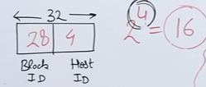

### ADDRESS BLOCK ASSIGNING RULES

1. The addresses in a block must be contiguous.
2. The number of addresses in a block must be a power of 2
3. The **first** address must be evenly divisible by the **number** of addresses

### FIRST, LAST & NO. OF ADDRESSES

The first address in the block can be found by setting the **rightmost 32-n bits to 0**.

The last address in the block can be found by setting the **rightmost 32-n bits to 1**.

Total Addresses : 2**32-n**

**-**

### NETWORK ADDRESS

The first address is called the network address and defines the organization network.

First address is the one that is used by routers to direct the message sent to the organization from the outside.

### SUBNETTING

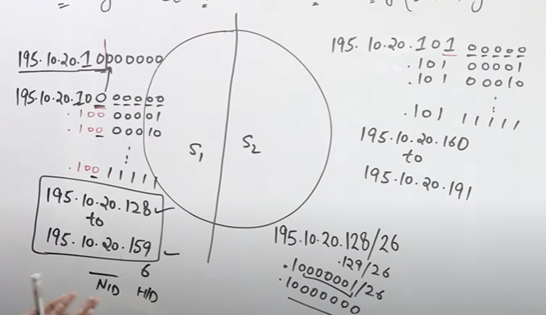

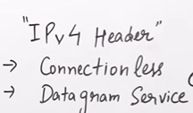

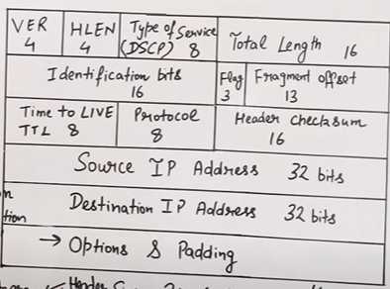

## NETWORK LAYER PROTOCOLS

### IP

### ICMP

### ARP

To map a known IP address to a MAC address in a local network.  
IP addresses operate at network layer, while MAC addresses operate at data link layer.

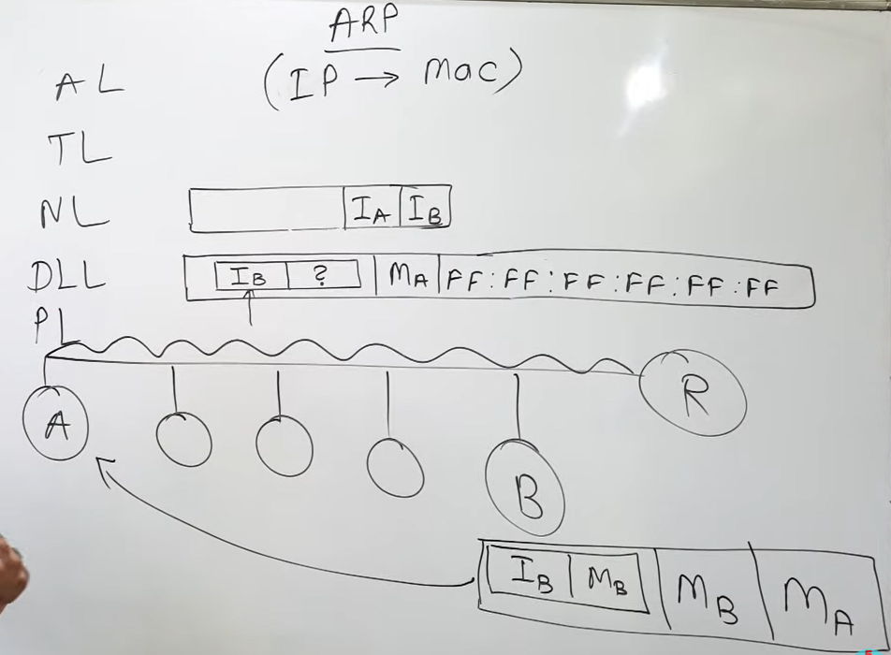

**HOW ?**

* Host A broadcasts an ARP Request, Sent to all devices on the LAN.
* Host B receives the request, recognizes its own IP
* Then replies with its MAC address directly to Host A (unicast).
* Host A receives the reply and updates its ARP cache (Temporary memory inside hosts and routers storing IP-to-MAC mappings.).
* It now sends the data directly to Host B’s MAC address.

### RARP

## ROUTING PROTOCOLS -

Routers forward packets to network not to host, this makes routing tables smaller

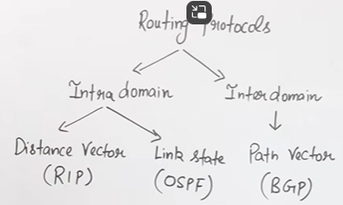

Main function of network layer -   
Forwarding of packets

Done via routers

Opens the packet, chooses optimal path, uses routing tables

INTRADOMAIN – Within Autonomous area  
INTERDOMAIN – Among 2 different autonomous areas

### RIP (DISTANCE VECTOR ROUTING)

* Intra domain routing protocol, within autonomous system
* Routers share information with **direct neighbors**.

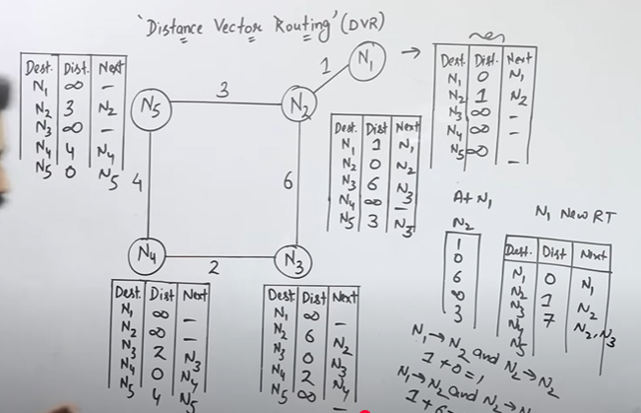

**OSPF (LINK STATE ROUTING)**

